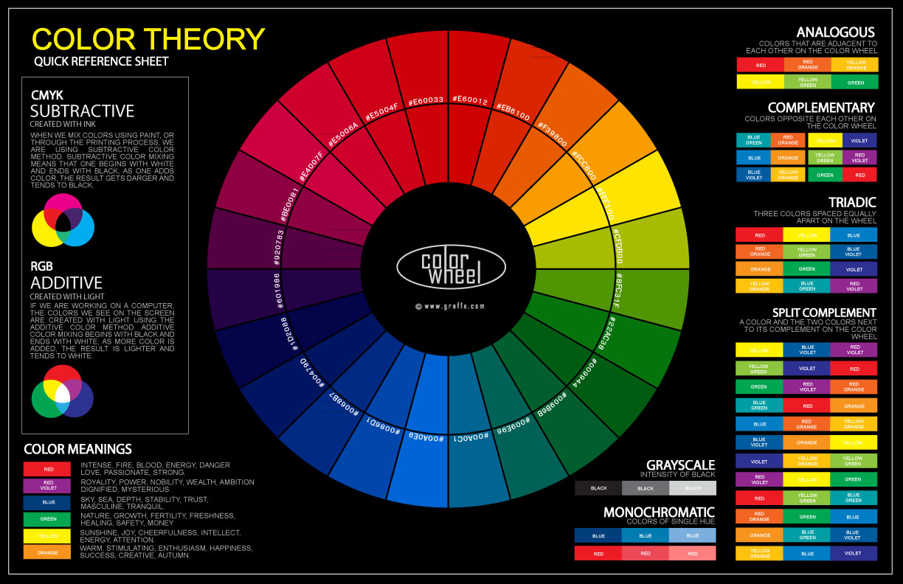

Different colours visually represents different meanings to the player and sets the mood of the environment to the game. The Colour wheel is a basic tool for combining primay, secondary, and teritary etc colours and was first created by Sir Isaac Newton in 1666. (tigercolor, n.d.).

The primary objective for this goal is to find colour schemes that fit with both Thomas’s realistic props and backgrounds to be implemented later into the game, and the way to achieve this is by using greyscale saturation and desaturation, basically the difference between light and shadow in art. (Lux, 2014).



Back during World War II, Submarines were painted grey to camouflage in the shadows to hide more easily from their oppents. (Cole, 2017). Using a dark blue colour palette From my research, I choosed the apporiate colour schemes to be used for the players sprite.

References:

ColorHex (n.d.). *Shades of Gray Color Palette*. [online] Color-hex.com. Available at: http://www.color-hex.com/palettes/184.png [Accessed 5 Mar. 2018].

lycoris (n.d.). *Blue Hour Color Palette*. [online] Color-hex.com. Available at: http://www.color-hex.com/palettes/16324.png [Accessed 5 Mar. 2018].

Tigercolor (n.d.). *Basic color schemes: Color Theory Introduction*. [online] Tigercolor.com. Available at: http://www.tigercolor.com/color-lab/color-theory/color-theory-intro.htm [Accessed 5 Mar. 2018].

Famusjgc. (2014). *Basic Color Theory*. [online] Famusjgc.wordpress.com. Available at: https://famusjgc.files.wordpress.com/2014/01/color-wheel.jpg [Accessed 5 Mar. 2018].

Rafael (2017). *Gradient “white mark” optical illusion*. [online] Graphicdesign.stackexchange.com. Available at: https://i.stack.imgur.com/Lvf0P.png [Accessed 5 Mar. 2018].

Lux (2014). *Color Relativity: Color Theory Beyond the Wheel*. [online] Purplepwny.com. Available at: http://purplepwny.com/blog/color_relativity_color_theory_beyond_the_wheel.html [Accessed 5 Mar. 2018].

Cole, T. (2017). *Why were some (perhaps all) of the WWII submarines painted gray instead of black which is the standard colour for submarines today?*. [online] Quora.com. Available at: https://www.quora.com/Why-were-some-perhaps-all-of-the-WWII-submarines-painted-gray-instead-of-black-which-is-the-standard-colour-for-submarines-today [Accessed 5 Mar. 2018].